**1.Introduction**

This assignment will help you to consolidate the concepts learnt in the session. **2.Problem Statement**

1. Install Jupyter notebook and run the first program and share the screenshot of the output. LINK

1. Write a program which will find all such numbers which are divisible by 7 but are not a multiple of 5, between 2000 and 3200 (both included). The numbers obtained should be printed in a comma-separated sequence on a single line.

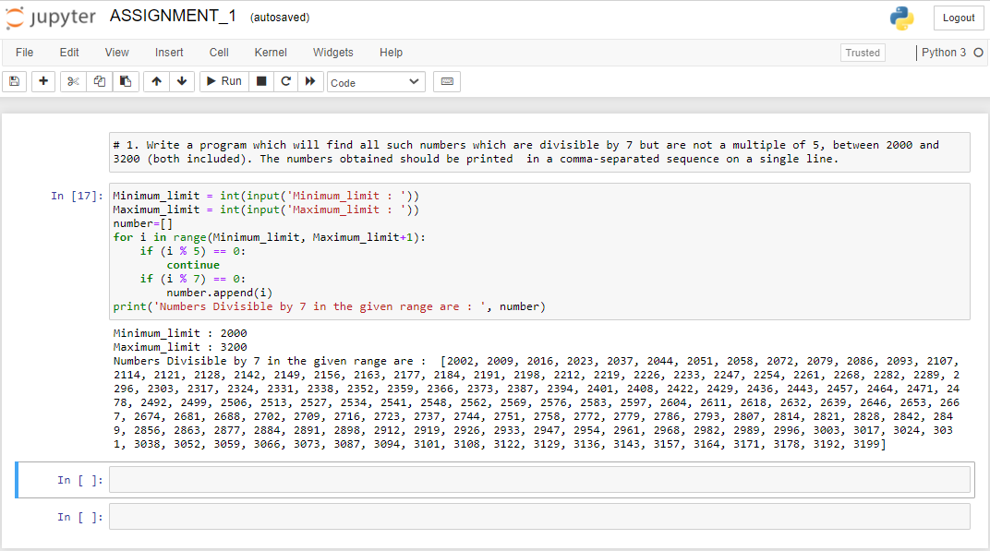

2. Write a Python program to accept the user's first and last name and then getting them printed in the the reverse order with a space between first name and last name.

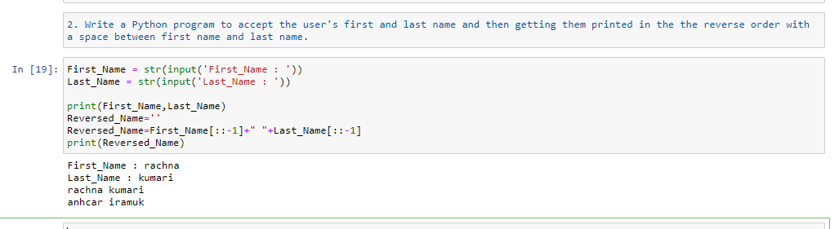

3. Write a Python program to find the volume of a sphere with diameter 12 cm.Formula: V=4/3 * π * r 3

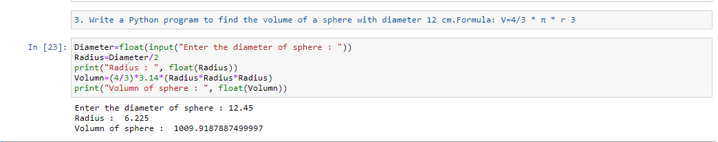

**NOTE:ThesolutionsharedthroughGithubshouldcontainthesource codeused and the screenshotoftheoutput.**

**3.Output**

This assignment consists of 200 marks and the solution file needs to be submitted in the upcoming session in .ipynb format for evaluation.